Date:-03/07/2025
Report

Introduction
Information Technology (IT) has become an essential component of modern life, shaping the way we work, communicate, and solve problems. With rapid advancements in digital technologies, IT offers diverse and rewarding career paths. This report provides comprehensive career guidance for individuals aspiring to build a successful career in the IT industry.
Importance of IT in the Modern World
Information Technology plays a vital role across all sectors, including education, healthcare, finance, entertainment, manufacturing, and government. Key reasons why IT is a promising career field include:
High demand for skilled professionals
Opportunities for innovation and creativity
Competitive salaries and career growth
Global job opportunities
Flexibility in work environment (remote work)
- Software Development
Roles: Software Engineer, Web Developer, Mobile App Developer
Skills: Programming languages (Python, Java, C++), problem-solving, version control
Opportunities: Product development, app creation, freelancing, startup innovation
- Cybersecurity
Roles: Security Analyst, Ethical Hacker, Security Consultant

Skills: Network security, cryptography, ethical hacking, risk assessment
Certifications: CEH, CompTIA Security+, CISSP
- Data Science and Artificial Intelligence
Roles: Data Scientist, Machine Learning Engineer, Data Analyst
Skills: Python, R, SQL, data visualization, statistics, AI models
Tools: TensorFlow, Power BI, Pandas, Scikit-learn
- Cloud Computing and DevOps
Roles: Cloud Engineer, DevOps Engineer, Site Reliability Engineer (SRE)
Skills: AWS, Azure, Docker, Kubernetes, CI/CD pipelines
Certifications: AWS Certified Solutions Architect, Microsoft Azure Fundamentals
- Networking and System Administration
Roles: Network Engineer, System Administrator, IT Support Specialist
Skills: Networking protocols, server management, Linux/Windows systems
Certifications: CompTIA Network+, Cisco CCNA
- UI/UX and Design
Roles: UI Designer, UX Researcher, Product Designer
Skills: Figma, Adobe XD, HTML/CSS, user interface design, usability testing

Co-ordinator Head of Department

Date 03/07/2025
Photo Gallery
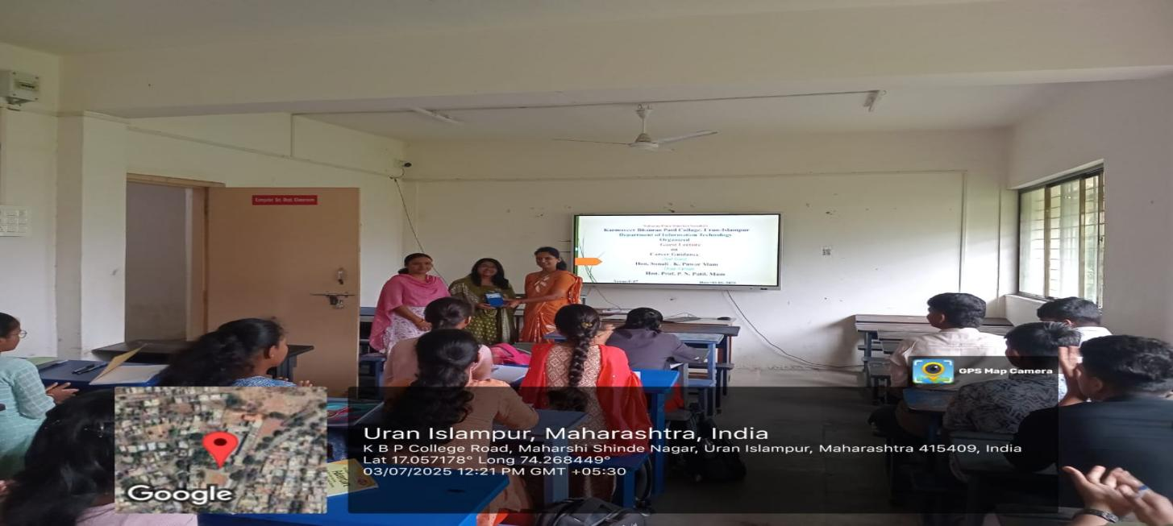
Facilitating guest

Student Present for lecture

