Mahatma Phule Shikshan Sanstha’s
Karmaveer Bhaurao Patil College, Urun-Islampur
Department of Mathematics
Alumni 2022-23
Sr. No. | Name of Student
1 | Chavan Vrushali Arvind
2 | Jadhav Komal Mohan
3 | kamble Pallavi Shankarrao
4 | Karpe Saraswati Appasaheb
5 | Khot Sujit Subhash
6 | Kumbhar Ashvini Govindrao
7 | Lugade Aarti Ananda
8 | Malavekar Sourabh Akaram
9 | Mali Nikita Chandrakant
10 | Mane Poonam Ananda
11 | Mohite Sonal Shankar
12 | More Komal Sunil
13 | Patil Asharani Dilip
14 | Patil Manjusha Shankar
15 | Patil Pratiksha Manik
16 | Patil Sangita Sanjay
17 | Pawar Prajakta Vikas
18 | Phalle Madhuri Pravin
19 | Salunkhe Amit Dhanaji
20 | Salunkhe Samiksha Hanmant
21 | Shelar Sushant Ashok
22 | Shinde Ankita Jitendra
23 | Shinde Pranjali Pradip
24 | Talap Amruta Bajirao
25 | Vasamale Anuja Dattatray

Mahtam Phule Shikshan Sanstha’s
KARMAVEER BHAURAO PATIL COLLEGE, URUN - ISLAMPUR.
DEPARTMENT OF MATHEMATICS
MENTOR- MENTEE SCHEME 2025-26
M.Sc. II (Maths)

Date: 03/09/2025
1st Meeting Notice

All the Mentees here by are informed that, the meeting of Mentees will be held on 04/09/2025 at 11.30 a.m. for mentor – mentee intraction. So all the mentees should be remain present for the meeting in time.
Venue ;- G - 11

Miss R. S. Yadav
Mentors

Mahtam Phule Shikshan Sanstha’s
KARMAVEER BHAURAO PATIL COLLEGE, URUN - ISLAMPUR.
DEPARTMENT OF MATHEMATICS
MENTOR- MENTEE SCHEME 2025-26
M.Sc. II (Maths)

Date: 04/09/2025
Minutes of the Meeting 1st

As per notice informed on 03/09/2025, The meeting of mentor – mentee has been conducted on 04/09/2025at 11.30 a.m. in G-11 .The meeting was interactive to get introduction of mentor – mentee scheme and how to implement this scheme effectively. All Studens inform that fill the examination forms in time.
A ward namely Rutuja Naikavadi presented vote of thanks.

Miss R. S. Yadav
Mentors

Mahatma Phule Shikshan Sanstha’s
Karmaveer Bhaurao Patil College, Urun-Islampur
Department of Mathematics
 | Class- M.Sc. II Mathematics
Name of Mentor: Miss. Yadav Rohini S.
Sr.no | Name of Student | Mobile.No. | Signature
1 | Inamdar Saniya Mansur | 7743996098
2 | Karande Gayatri Dhanajirao | 7558218229
3 | Naikavadi Rutuja Kumar | 9657958090
4 | Patil Shruti Sardar | 8010192030
5 | Patil Swapnali Anil | 9021520788

All Students Exam form are Submitted

Mahatma Phule Shikshan Sanstha’s
Karmaveer Bhaurao Patil College, Urun-Islampur
Department of Mathematics
M. Sc. II (Maths) (2025-26)

Date: 16/09/2025

2nd Meeting Notice

All the Mentees here by are informed that, the meeting of Mentees will be held on 17/ 09 / 2025 at 11.30 a.m for mentor – mentee intraction. So all the mentees should remain present for the meeting in time.
Venue : - G – 11

Miss R. S. Yadav
Mentors

Mahatma Phule Shikshan Sanstha’s
Karmaveer Bhaurao Patil College, Urun-Islampur
Department of Mathematics
Mentor-Mentee Scheme 2025-26

Date: 17/09/2025

Minutes of the Meeting 2nd

As per notice informed on 16/09/2025, The meeting of mentor – mentee has been conducted on 17/09/2025 at 11.30 a.m. in G11.The meeting was monitor the student attendance and inform to students for parent teacher meeting , Also monitor the registration of examination of mentee students.
A ward namely Patil Shruti presented vote of thanks.

Miss R. S. Yadav
Mentors

Mahatma Phule Shikshan Sanstha's
KARMAVEER BHAURAO PATIL COLLEGE, URUN-ISLAMPUR

Department Mathematics
M.Sc.(Mathematics) Part-II
Report on

PARENT- TEACHER MEET
(2025-2026)

Date and Time : 04/10/2025 ,11.00 am To 02.00 pm
Venue: Room No. G 11

The Department of Mathematics organized a Parent-Teacher Meeting with the main purpose of creating a common platform where teachers and parents can come together to enrich students' educational experiences and discuss various issues regarding their all-round development.

Agenda
- Welcome and Introduction: Introduce faculty members and staff.
- Support and Resources: Overview of available academic support and counseling services, along with a discussion on parental involvement and support strategies.
- Academic Progress: Review of academic performance in various subjects.
- Future Goals: Setting academic goals for the next term.

Meeting Summary
The Parent-Teacher Meeting began with a welcome address and introductory speech by Mrs. K.M. Patil. She explained the objectives of the meeting, emphasizing the importance of familiarizing parents with the department where their children are studying and introducing them to the teachers. She also provided an overview of the department's progress and the courses offered.
Next, parents were invited to express their thoughts and provide interactive suggestions. Parent representatives Miss. Naikavadi Rutuja and Mrs. Sneha Patil appreciated the efforts of the Mathematics Department and expressed satisfaction with students’ achievements in both curricular and extracurricular activities. They suggested stricter enforcement of daily attendance and recommended that parent meetings be organized every semester during the academic year.
The meeting concluded with a vote of thanks from Prof. R.S. Yadav.

SEM 4

Mahatma Phule Shikshan Sanstha’s
Karmaveer Bhaurao Patil College, Urun-Islampur
Department of Mathematics
 | Class- M.Sc. II Mathematics
Name of Mentor: Miss. Yadav Rohini S.
Sr.no | Name of Student | Mobile.No. | Signature
1 | Patil Prathamesh Vishwas | 7744053611
2 | Chavan Radhika Sadashiv | 9307186663
3 | Nathgosavi Manaswi Babasaheb | 9518919248
4 | Tamboli Swaliha Mubarak | 7387900157
5 | Kamble Pranali Ajit | 9075049402
6 | Salunkhe Madhuri Sharad | 9552746397
7 | Kamble Sai Pradip | 8208579848

Mahtam Phule Shikshan Sanstha’s
KARMAVEER BHAURAO PATIL COLLEGE, URUN - ISLAMPUR.
DEPARTMENT OF MATHEMATICS
MENTOR- MENTEE SCHEME 2024-25

Date: 04/03/2025
1st Meeting Notice

All the Mentees here by are informed that, the meeting of Mentees will be held on 05/03/2025 at 11.30 a.m. for mentor – mentee intraction. So all the mentees should be remain present for the meeting in time.
Venue ;- G - 11

Miss R.S. Yadav
Mentors

Mahtam Phule Shikshan Sanstha’s
KARMAVEER BHAURAO PATIL COLLEGE, URUN - ISLAMPUR.
DEPARTMENT OF MATHEMATICS
MENTOR- MENTEE SCHEME 2024-25

Date: 05/03/2025
Minutes of the Meeting 1st

As per notice informed on 04/03/2025, The meeting of mentor – mentee has been conducted on 05/03/2025 at 11.30 a.m. in G-11 .The meeting was interactive to get introduction of mentor – mentee scheme and how to implement this scheme effectively. All Studens inform that fill the examination forms in time.
A ward namelyMadhuri Salunkhe presented vote of thanks.

Mahatma Phule Shikshan Sanstha’s
Karmaveer Bhaurao Patil College, Urun-Islampur
Department of Mathematics
 | Class- M.Sc. II Mathematics
Name of Mentor: Miss. Yadav Rohini S.
Sr.no | Name of Student | Mobile.No. | Signature
1 | Patil Prathamesh Vishwas | 7744053611
2 | Chavan Radhika Sadashiv | 9307186663
3 | Nathgosavi Manaswi Babasaheb | 9518919248
4 | Tamboli Swaliha Mubarak | 7387900157
5 | Kamble Pranali Ajit | 9075049402
6 | Salunkhe Madhuri Sharad | 9552746397
7 | Kamble Sai Pradip | 8208579848

All Students Exam form are Submitted

Photo Gallery:
M.Sc.(Mathematics) Part-II:
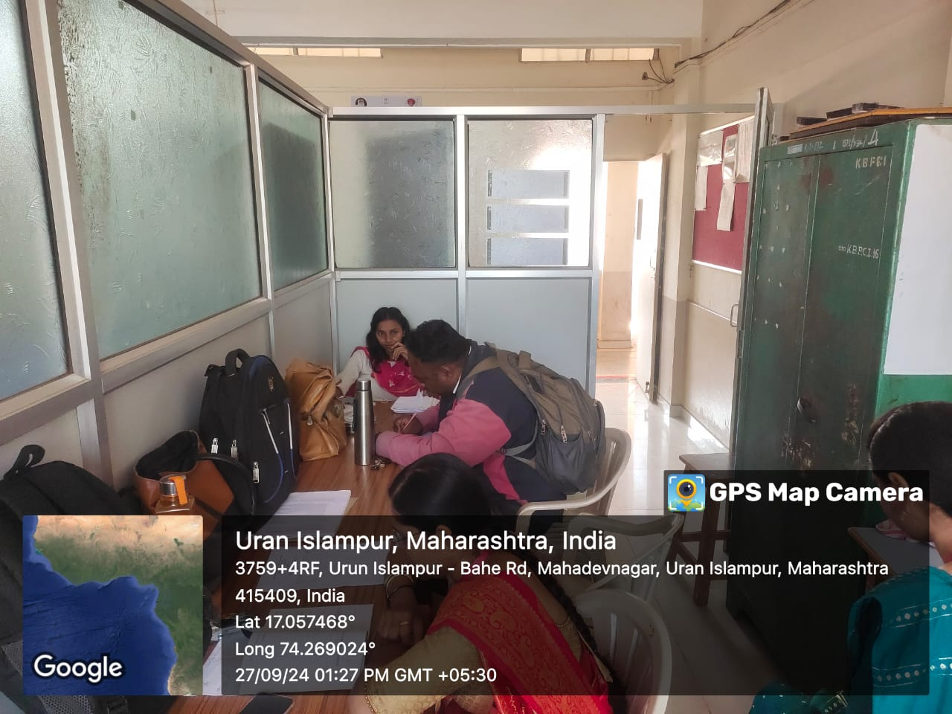
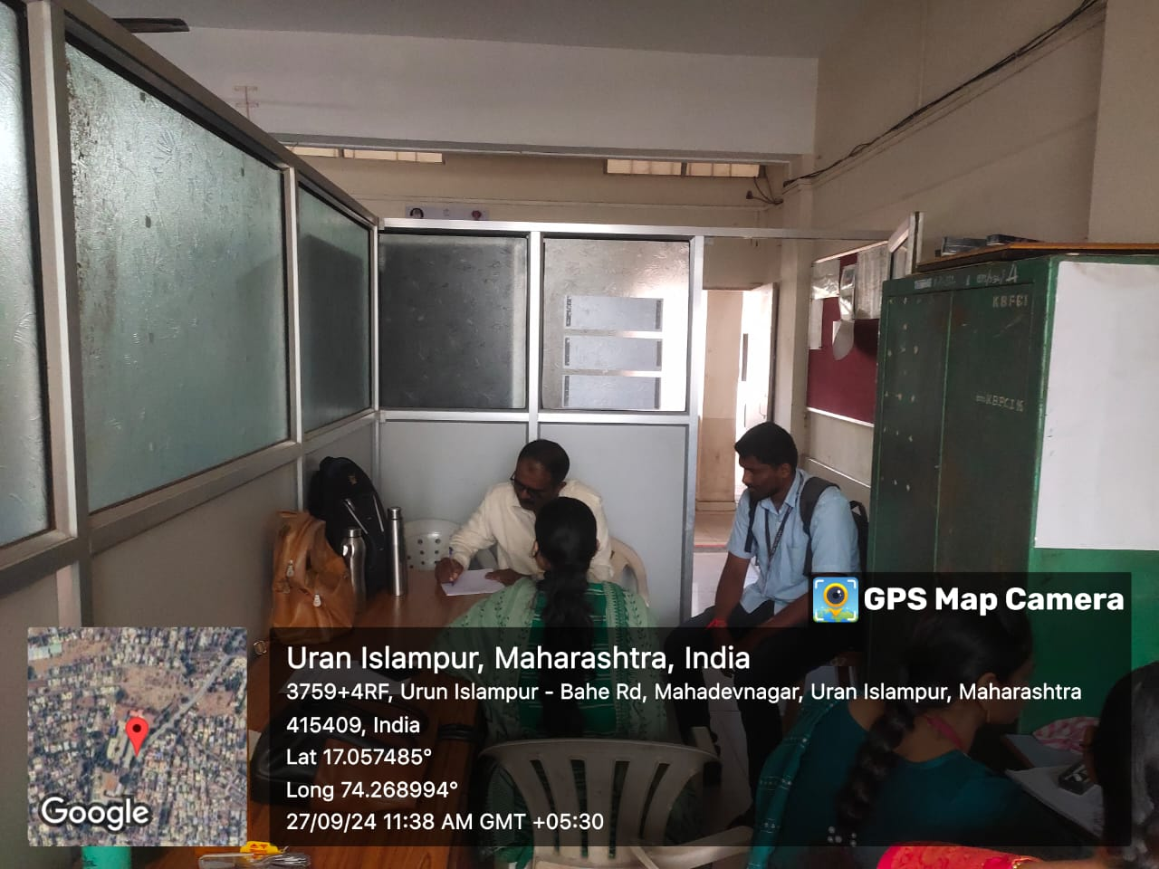
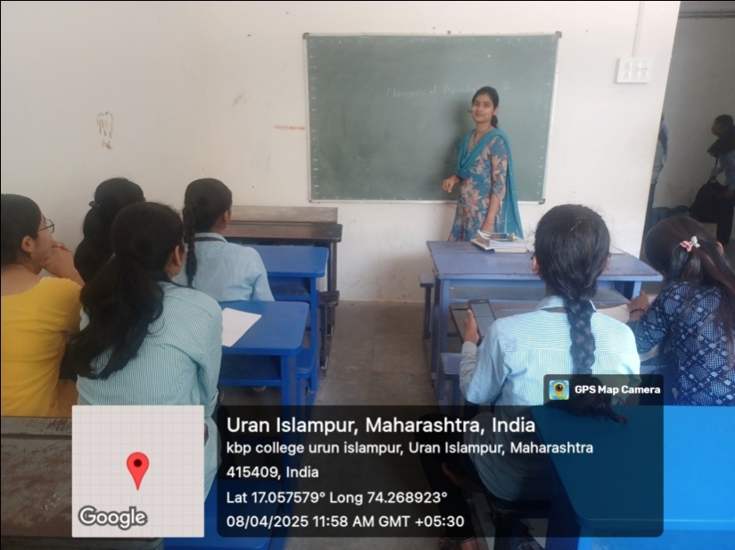
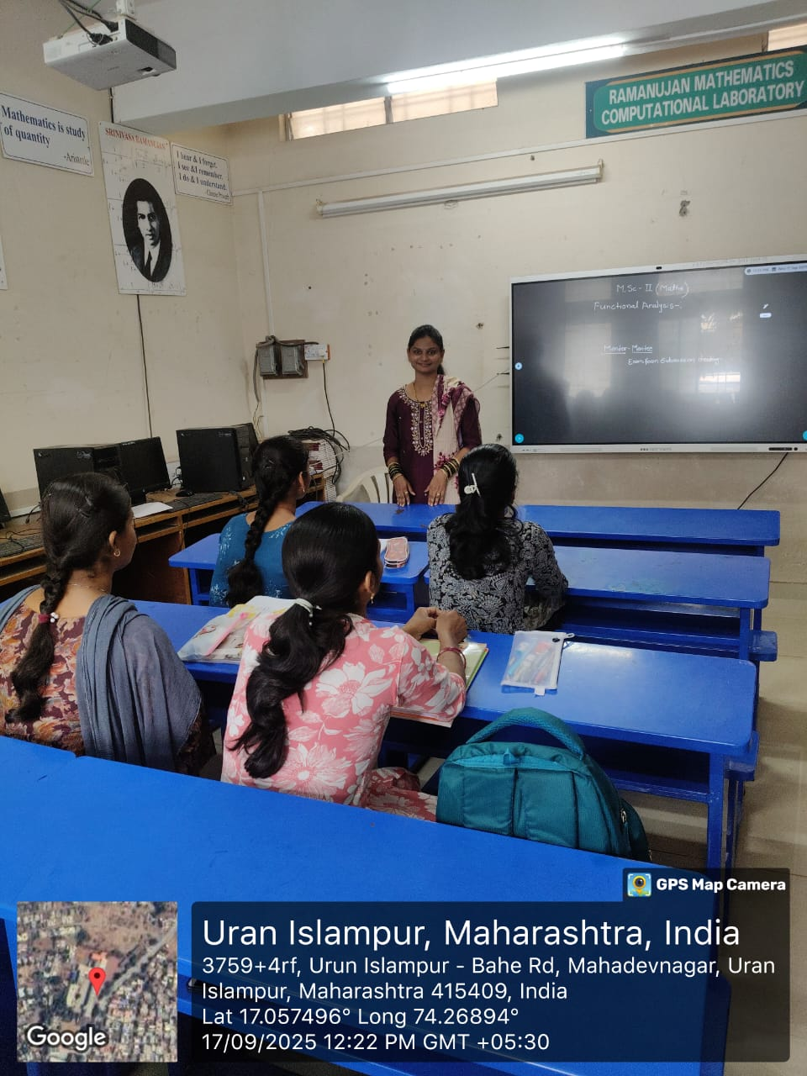
Head of Department
Mahatma Phule Shikshan Sanstha’s
Karmaveer Bhaurao Patil College, Urun-Islampur
Department of Mathematics
Class- M.Sc. II Mathematics
Mentor Mentee Parent Meeting (2025 -26)

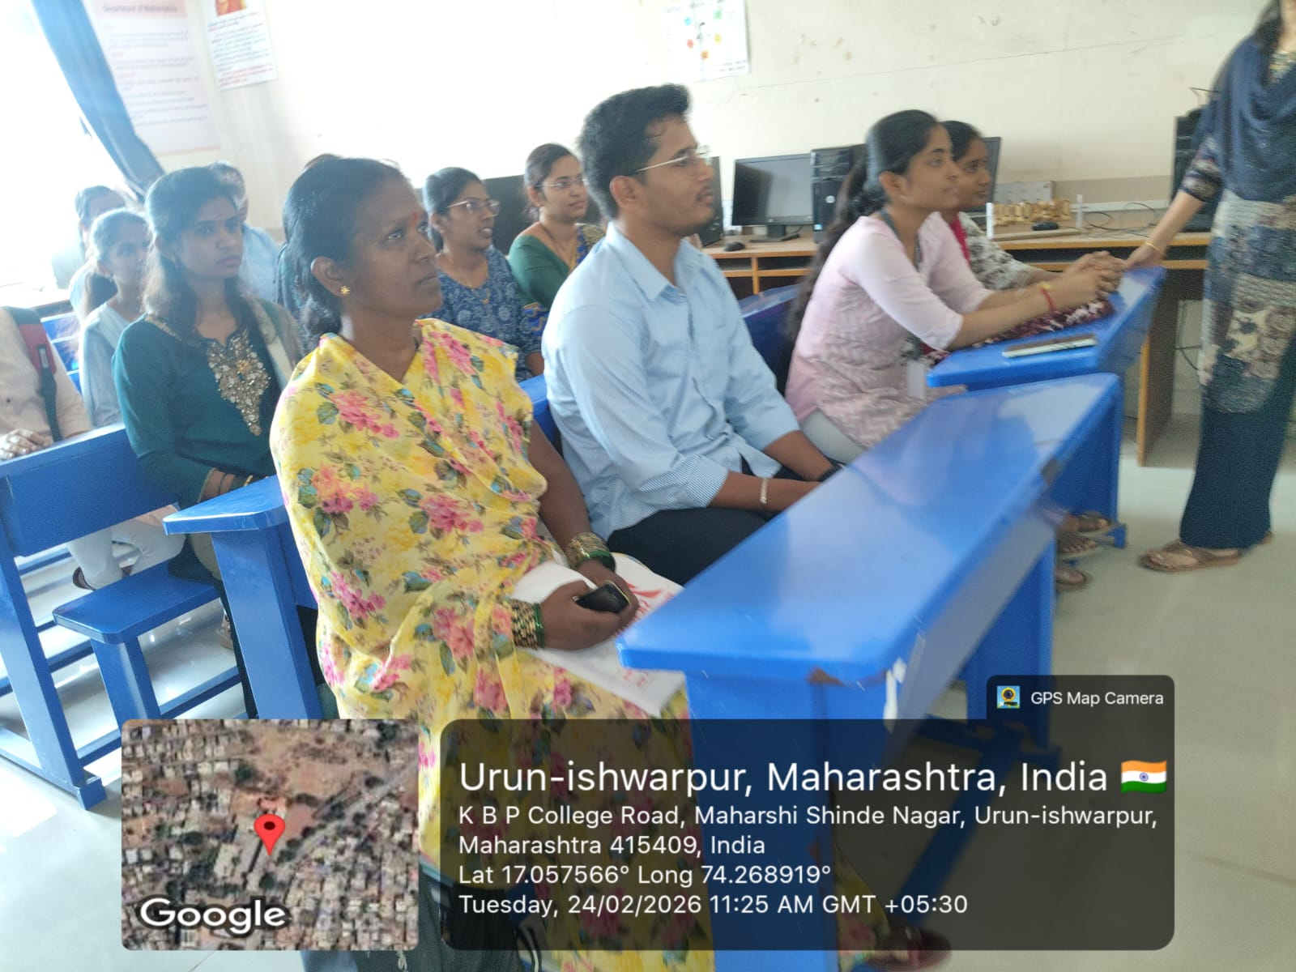

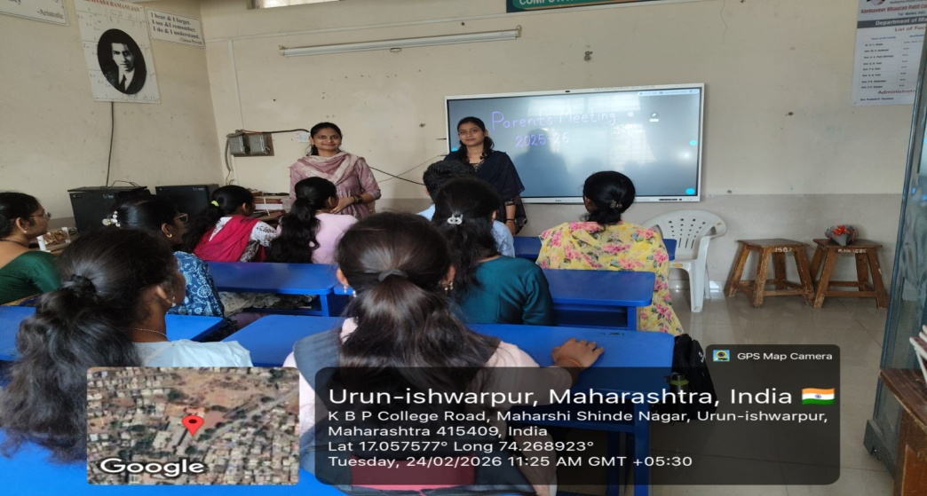

Mahatma Phule Shikshan Sanstha’s
Karmaveer Bhaurao Patil College, Urun-Islampur
Department of Mathematics
Class- M.Sc. II Mathematics
Name of Mentor : Miss Yadav Rohini S.

Sr.no | Name of Parents | Signature
1
2
3
4
5

Mahatma Phule Shikshan Sanstha’s
Karmaveer Bhaurao Patil College, Urun-Islampur
Department of Mathematics
 | Class- M.Sc. II Mathematics
Name of Mentor: Miss. Yadav Rohini S.
Sr.no | Name of Student | Mobile.No. | Signature
1 | Inamdar Saniya Mansur | 7743996098
2 | Karande Gayatri Dhanajirao | 7558218229
3 | Naikavadi Rutuja Kumar | 9657958090
4 | Patil Shruti Sardar | 8010192030
5 | Patil Swapnali Anil | 9021520788

Mahtam Phule Shikshan Sanstha’s
KARMAVEER BHAURAO PATIL COLLEGE, URUN - ISLAMPUR.
DEPARTMENT OF MATHEMATICS
MENTOR- MENTEE SCHEME 2025-26
M.Sc. II (Maths) (Sem IV)

Date: 16/01/2025
1st Meeting Notice

All the Mentees here by are informed that, the meeting of Mentees will be held on 17/01/2025 at 11.30 a.m. for mentor – mentee intraction. So all the mentees should be remain present for the meeting in time.
Venue ;- G - 11

Miss R. S. Yadav
Mentors

Mahtam Phule Shikshan Sanstha’s
KARMAVEER BHAURAO PATIL COLLEGE, URUN - ISLAMPUR.
DEPARTMENT OF MATHEMATICS
MENTOR- MENTEE SCHEME 2025-26
M.Sc. II (Maths)

Date: 17/01/2025
Minutes of the Meeting 1st

As per notice informed on 16/01/2025, The meeting of mentor – mentee has been conducted on 17/01/2025at 11.30 a.m. in G-11 .The meeting was interactive to get introduction of mentor – mentee scheme and how to implement this scheme effectively. All Studens inform that fill the examination forms in time.
A ward namely Rutuja Naikavadi presented vote of thanks.

Miss R. S. Yadav
Mentors

Mahatma Phule Shikshan Sanstha’s
Karmaveer Bhaurao Patil College, Urun-Islampur
Department of Mathematics
 | Class- M.Sc. II Mathematics
Name of Mentor: Miss. Yadav Rohini S.
Sr.no | Name of Student | Mobile.No. | Signature
1 | Inamdar Saniya Mansur | 7743996098
2 | Karande Gayatri Dhanajirao | 7558218229
3 | Naikavadi Rutuja Kumar | 9657958090
4 | Patil Shruti Sardar | 8010192030
5 | Patil Swapnali Anil | 9021520788

All Students Exam form are Submitted

